“FCL e-book”: Table of Contents. V3.0

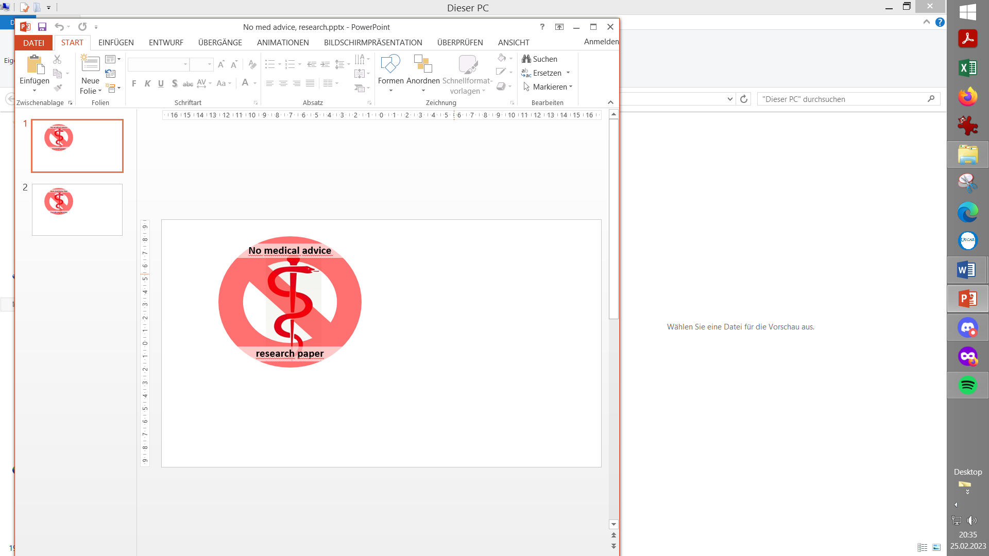

**0. Introduction**

**1. Pre-requisites for Full Closed Loop**

1.1 Well tuned hybrid closed loop

1.2 Fast insulin

1.3 Reliable insulin delivery from pump and cannula

1.4 Excellent CGM

1.5 Meal-related limitations?

1.6 Lifestyle-related limitations?

1.7 Time required for setting-up

Case study 1.1: Occlusion

Case study 1.2: Comparing insulins for FCL

Case study 1.3: Jumpy CGM

Case study 1.4: Lost pump connection

Case study 1.5: Permanent CGM values w/ 2x G6

**2. General Settings for Full Closed Loop**

2.1 SMB range extension

2.2 Max and min autoISF ratio

2.3 SMB delivery ratio

2.4 iobTH (iob_threshold_percent)

2.5 Eating Soon TT?

2.6 General settings in AAPS/Preferences

**3. Description of autoISF / guidance by developers**

3.1 Overview

3.2 ISF modulation flowcharts

3.3 Exercise mode and dynamic iobTH

3.4 Automation options with autoISF parameters

3.5 Activity monitor

3.6 Using one-minute CGM (Libre 3)

3.7 AutoISF parameters overview table

3.8 Emulator for logfile analysis and tuning

3.9 Links to related case studies/detailed doc.s

**4. Meals: Setting ISF_weights in AAPS/Preferences**

4.1 Getting started

4.2 bgAccel_ISF_weight

4.3 pp_ISF_weight

4.4 bgBrake_ISF_weight

*Skip what is in* ***green writing***: = Drafted fragments or not implemented ideas.

Please contribute, or wait for update with the missing info

4.5 dura_ISF_weight

4.6 Tuning your initial settings

4.7 Complex scenarios

4.8 Profile helper

Case study 4.1: Pizza

Case study 4.2: Low carb meals

Case study 4.3: Hands-off FCL around Christmas

**5. Temp. modulation of autoISF aggressiveness**

**5.1 Automatic modulation of loop aggressiveness**

5.1.1 autoISF off outside of meal windows

5.1.2 SMB off @ odd profile target

5.1.3 SMB off @ odd temp. target

5.1.4 Automatic diff. of FCL aggressiveness via Automations

5.1.5 Automatic diff. of FCL aggressiveness via Activity Monitor

5.1.6 Pro/con completely hands-off FCL

**5.2 Manual modulation of FCL aggressiveness via DIY cockpit**

5.2.1 Status recognition

5.2.2 Manual interventions from DIY cockpit

5.2.2.1 Temp. %profile or TT settings

5.2.2.2 Temp. settings in /preferences

5.2.2.3 Grey DIY cockpit buttons for pre-programmed FCL responses

5.2.3 Temporary exit from FCL

**5.4 Recognizing loop state from the AAPS home screen**

5.4.1 Color scheme (grey/yellow) of the top 3 fields (profile, exercise, TT)

5.4.2 Info on the top 3 fields (profile, exercise, TT)

5.4.3 FCL related indicator fields

5.4.4 Overall AAPS home screen

**5.4 Ideas for an improved cockpit**

*Skip what is in* ***green writing***: = Drafted fragments or not implemented ideas.

(Might be weeded out soon, many things not really needed)

5.3.1 Violet FCL icon and underlying buttons

5.3.2 Bottom buttons “insulin” etc.

5.3.3 Top three fields

5.3.3.1 TT dialogue field

5.3.3.2 Exercise button / dialogue field

5.3.3.3 Profile dialogue field

Case study 5.2: Sweet snacks / Glühwein w/ DIY cockpit

Case study 5.3: Compression low

**6. Temp. modulation for exercise and light (In-)activity**

**6.1 Dynamic iobTH and sensitivity ratio**

6.1.1 Manual (direct) iobTH modulation

6.1.2 Automations for iobTH modulation

6.1.3 Dynamic iobTH

**6.2 Temp. % profile switch**

**6.3 DIY cockpit based on User action Automations**

**6.4 Improved FCL cockpit**

*Skip what is in* ***green writing***: = Drafted fragments or not implemented ideas.

(Might be weeded out soon, many things not really needed)

6.4.1 Manual (direct) iobTH modulation

6.4.2 pre-set 4 kinds of exercise

6.4.3 optional meal pre-sets

6.4.4 optional hypo management pre-sets

**6.5 Mastering the exercise after meal challenge**

6.5.1 Manual mode

6.5.2 DIY cockpit button for User action Automation

6.5.3 Using pre-sets in improved FCL cockpit

**6.6 Activity monitor based on step-counter**

Case study 6.2 Biking day with hi carb lunch; DIY cockpit

**7. Advanced HCL (meal announcement via pre-bolus)**

7.1 Hurdles for FCL

7.2 Getting ready to advance from HCL

7.3 Reduced pre-bolus

7.4 Tuning autoISF in HCL

7.5 Dealing with disturbances/ins. sens/resistance

7.6 Exercise management

7.7 Remote control (small children) (fragment, to be completed NN)

7.8 Other methods w/ meal announcement (MA)

**8. Performance monitoring and tuning**

Case study 8.2: Futility of tuning based on 1 extreme meal

**9. Trouble shooting**

**10. Emulator on PC to determine settings**

10.1 Installing the Emulator on your PC

10.2 Analyzing loop decisions in logfiles

10.3 What-if analysis

**11. Emulator on the smartphone**

11.1 Installing the emulator on your smartphone

11.2 Checking loop decisions on the smartphone

11.3 Options available on i-Phone (for Trio or iAPS)

11.4 Real-time checking a „what-if“ question using speech synthesis

**12. Remarks for users of previous autoISF version**

**13. Other avenues to Full Closed Loop**

**13.1 FCL using AAPS Master and Automations**

Case study 13.1: Comparison 1 mo FCL Automation vs autoISF

**13.2 dynamicISF used for Full Closed Loop**

Case study 13.2: Using dynISF for FCL ( NN )

**13.3 Methods involving simple meal announcement that might be stretched into a FCL**

13.3.1 Boost

Case study 13.3: Boost-based FCL for a child

13.3.2 AIMI,

13.3.3 EatingNow

13.3.4 Tsunami

**13.4 No-bolus looping with precise carb Inputs**

**13.5 Machine Learning (AI)**

**13.6 Dual hormone systems**